NAAN MUDHALVAN PROJECT REPORT

**(SERVICE NOW)**

**TITLE:** Optimizing User, Group, and Role Management with Access Control and Workflows

**COLLEGE CODE:** 0110  
**COLLEGE:** Dharmamurthi Rao Bahadur Calavala Cunnan Chetty’s Hindu College

**TEAM ID:** NM2025TMID18332

|  |  |
| --- | --- |
| NAMES | NM ID |
| SAKTHIVEL M (LEADER) | 061377DE720A120A6714D7A78822A586 |
| VENKATANATHAN G | F34434C54BA526EB46A4D350B61A03E0 |
| KARTHICK S | 31778A2463ADA4988E4493BA404E7FAA |
| KARTHI R | 19E868768B8026BBA184C6259CE227DD |

**Team Members:**

1. Sakthivel M
2. Venkatanathan G
3. Karthick S
4. Karthi R

**Project Description**

This project focuses on creating a structured and efficient system for managing **users, groups, and roles** within a small project team. In the absence of a proper system, responsibilities often remain unclear, leading to confusion and delays.

The system includes the following:

* **Users:** Individuals who are part of the project (e.g., Alice and Bob).
* **Groups:** Teams or categories that organize users with similar roles.
* **Roles:** Specific responsibilities or permissions assigned to each user (e.g., Project Manager, Team Member).
* **Access Control:** Rules that define who can view, edit, or manage tasks.
* **Workflow:** A step-by-step process for assigning, tracking, and completing tasks.

For instance, the Project Manager (Alice) can assign tasks and monitor progress, while the Team Member (Bob) can update his work and mark tasks as complete. This ensures that all activities are transparent and easy to follow.

By the end of the project, the system provides **clear accountability, better collaboration, and improved tracking of progress**, making project management simple and effective.

**Implementation**

**1. Users**

Users are the members who take part in the project.

**Example:** Alice (Project Manager) and Bob (Team Member).

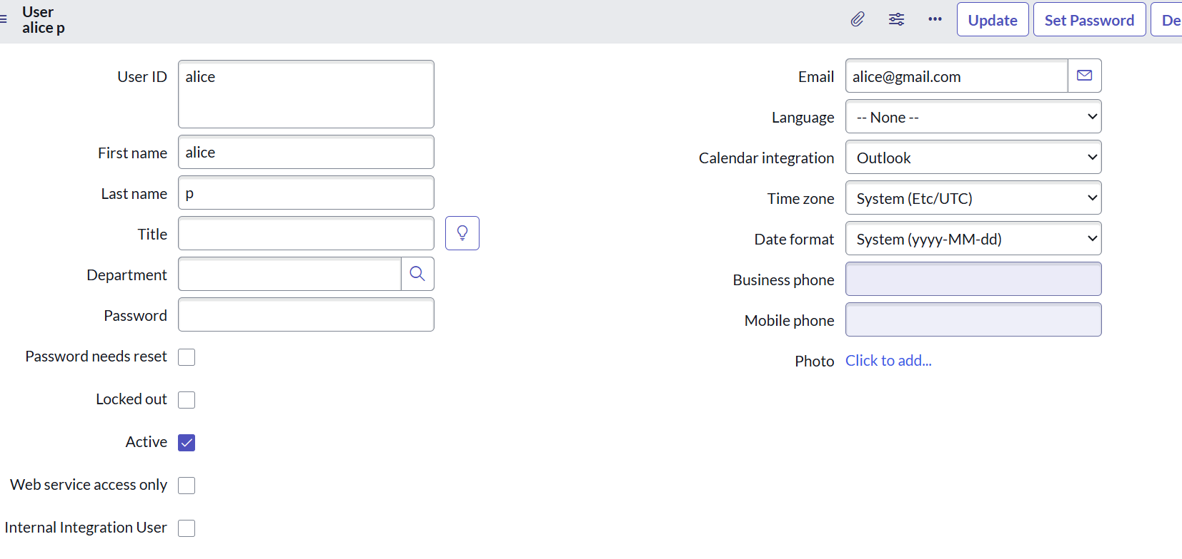

**Other user:**

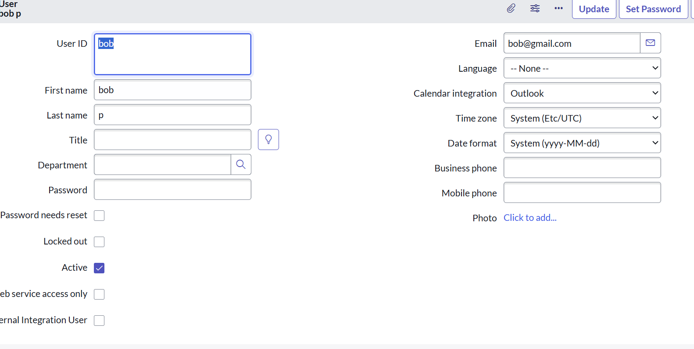

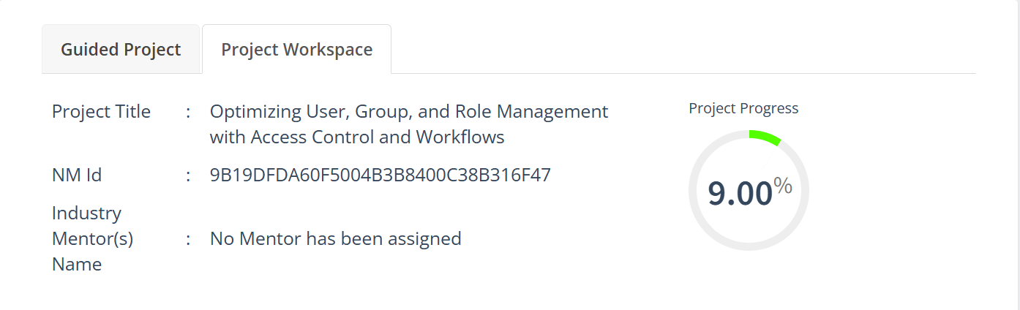

**2. Create Groups**

**To create a new group in ServiceNow:**

1. **Open ServiceNow.**
2. **In the left menu, click on All and search for Groups.**
3. **Under *System Security*, select Groups.**
4. **Click New and enter the *Group Name* and *Description*.**
5. **Click Submit to save the group.**

**Example Groups:**

* **Project Managers – for managing tasks and tracking progress.**
* **Team Members – for working on assigned tasks.**

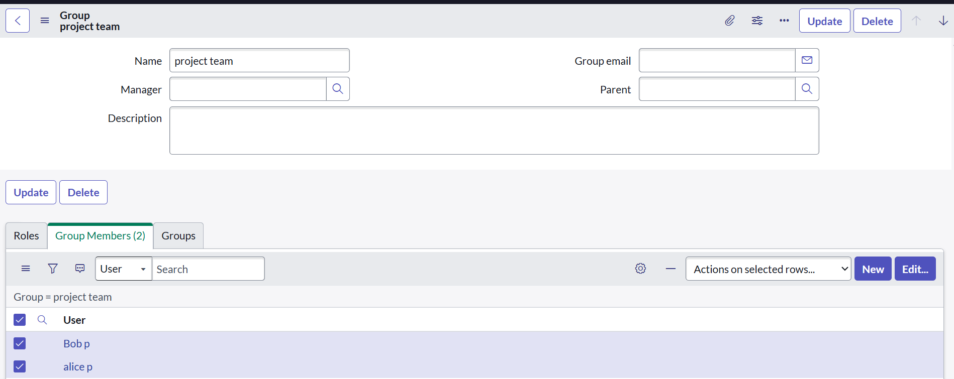

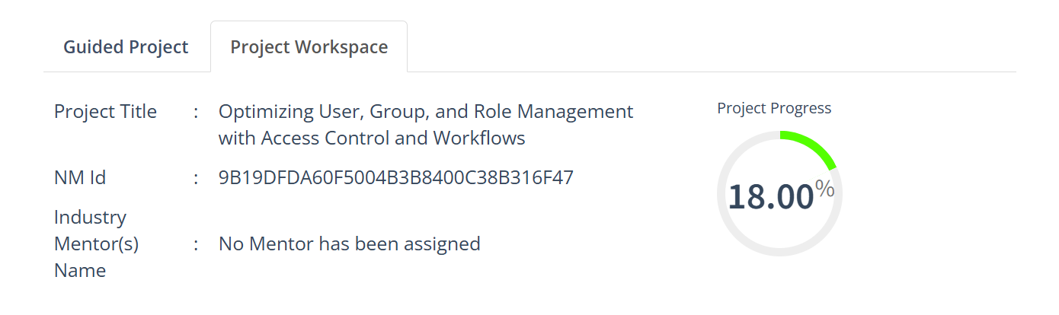

**3. Create Roles in ServiceNow**

1. **Open ServiceNow and log in.**
2. **In the left-hand menu, click All and search for Roles.**
3. **Under System Security, select Roles.**
4. **Click New to create a new role.**
5. **Fill in the required details:**
   * **Role Name – Give a meaningful name for the role.**
   * **Description – Briefly describe the role’s responsibilities.**
6. **Click Submit to save the role.**

**Example Roles:**

* **Project Manager Role – Can assign tasks, track progress, and manage the project.**
* **Team Member Role – Can view assigned tasks, update status, and complete work.**

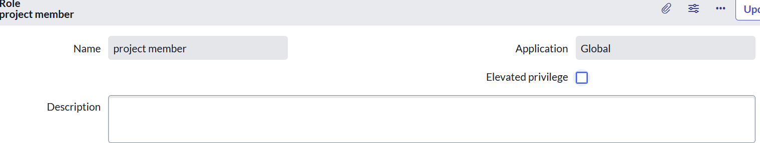

**Other users:**

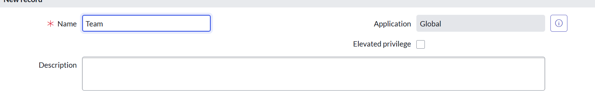

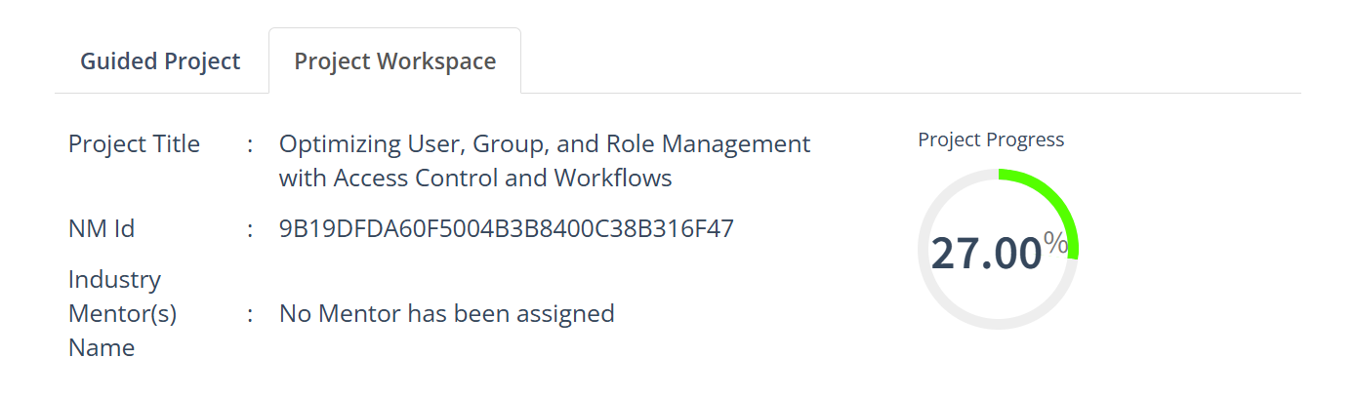

**3. Creating Roles in ServiceNow**

1. **Log in to ServiceNow.**
2. **Go to All → Roles from the left menu.**
3. **Under System Security, select Roles.**
4. **Click New to add a role.**
5. **Fill in the details:**
   * **Role Name – A descriptive name for the role.**
   * **Description – Brief summary of responsibilities.**
6. **Click Submit to save.**

**Example Roles:**

* **Project Manager – Can assign tasks, track progress, and manage projects.**
* **Team Member – Can view assigned tasks, update status, and complete work.**

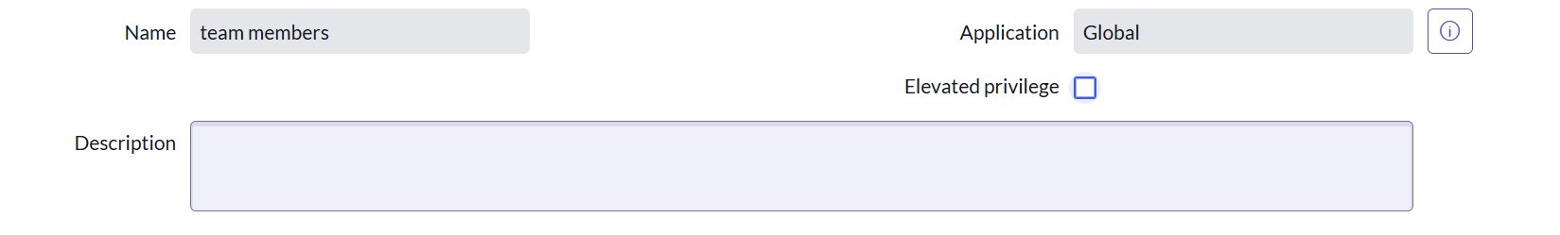

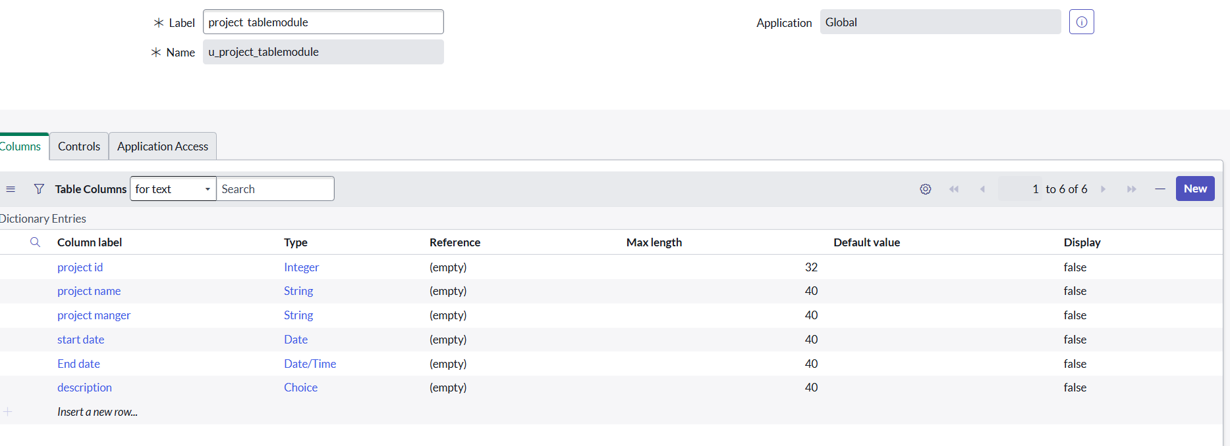

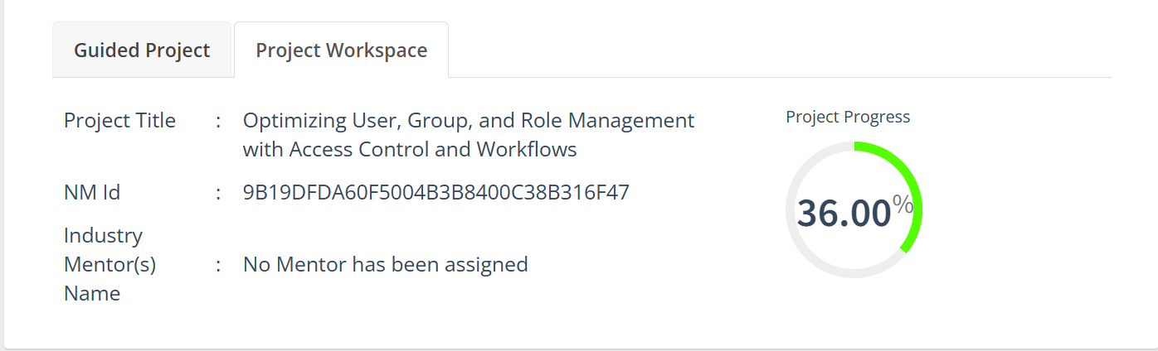

**5. Assign Users to Groups in ServiceNow**

1. **Log in to ServiceNow.**
2. **Navigate to All → Groups from the left menu.**
3. **Under System Security, select Groups.**
4. **Open the group where you want to add users.**
5. **In the Group Members section, click Edit.**
6. **Select the users you want to add.**
7. **Click the Add → button to include them in the group.**
8. **Click Save or Update to confirm the changes.**

**Example Assignments:**

* **Add Alice to the Project Managers group.**
* **Add Bob to the Team Members group.**



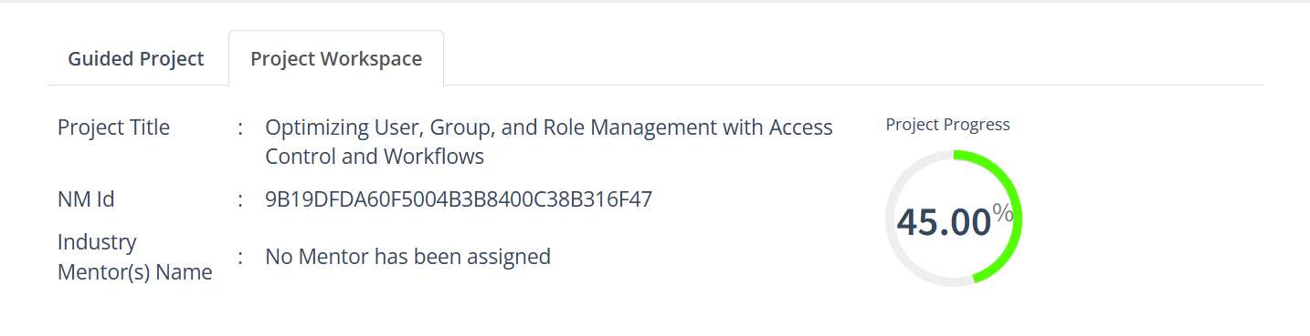

**6. Assign Roles to Alice (Project Manager) in ServiceNow**

1. **Log in to ServiceNow.**
2. **Navigate to All → Users from the left menu.**
3. **Under System Security, select Users.**
4. **Find and open Alice’s user record.**
5. **Scroll to the Roles tab and click Edit.**
6. **From the list of available roles, select Project Manager Role.**
7. **Click the Add → button to assign it to Alice.**
8. **Click Save or Update to confirm the assignment.**

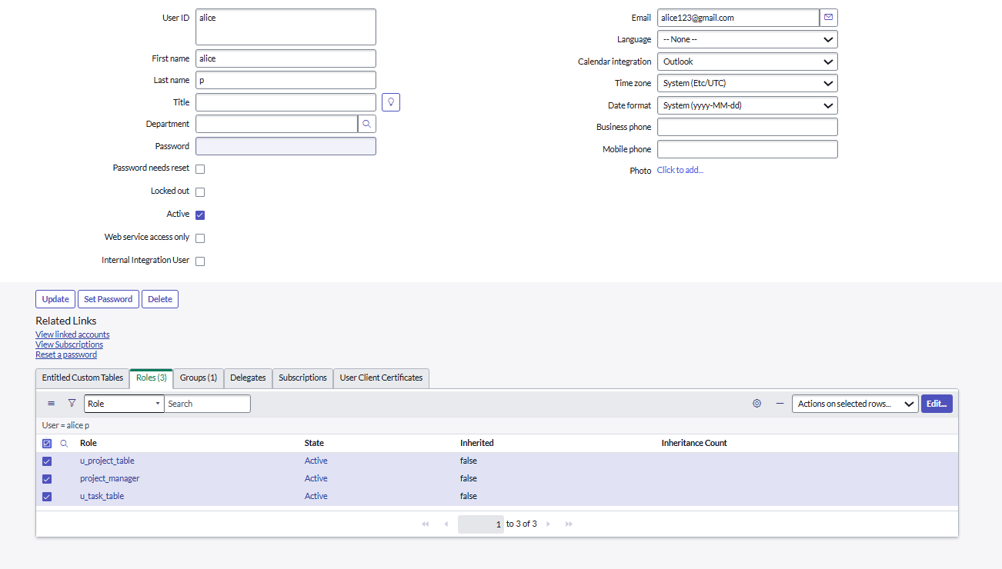

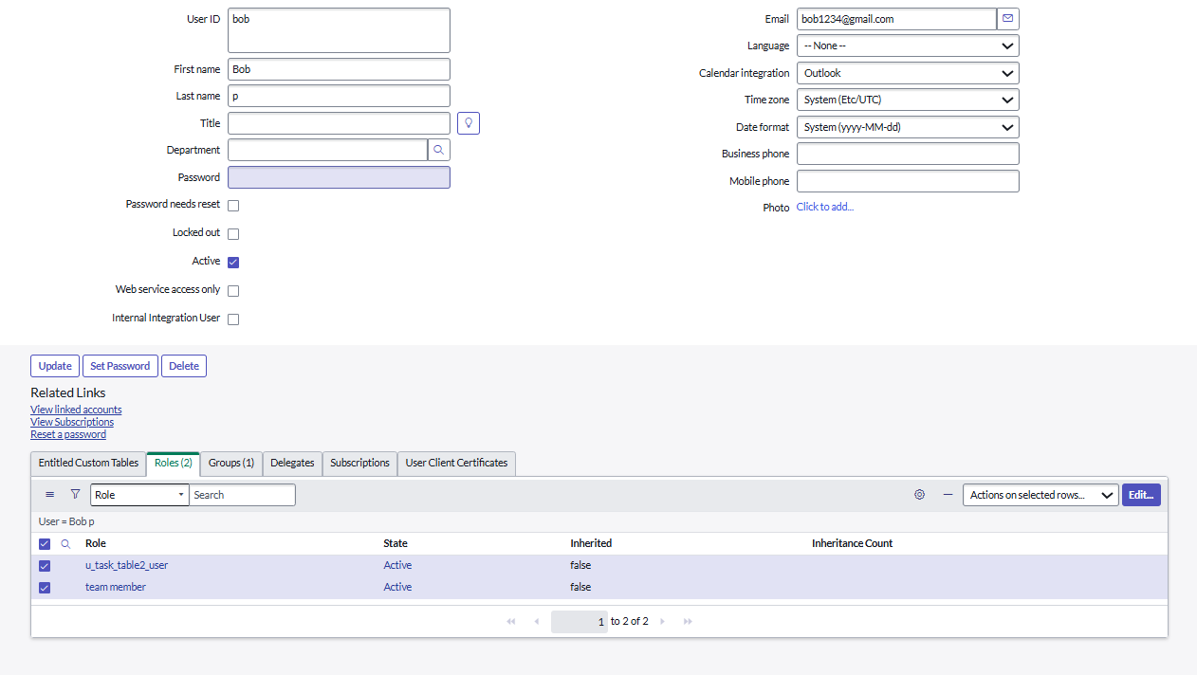

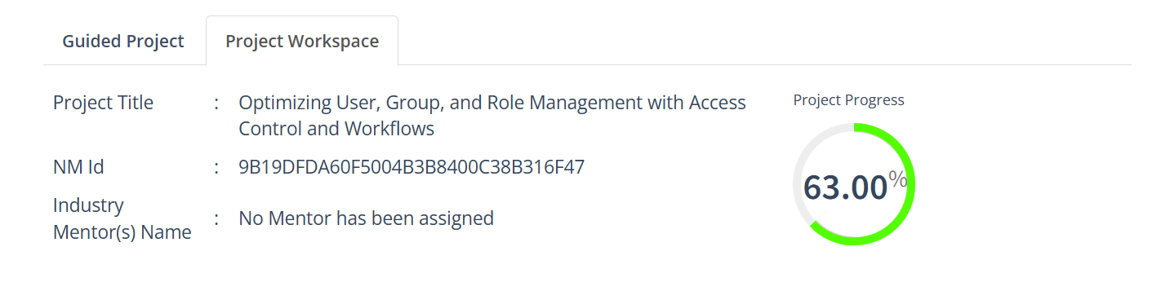

**7. Assign Table Access to Applications in ServiceNow**

1. **When you create a new table in ServiceNow, an Application and Module are automatically created for it.**
2. **Open the Application Navigator and search for your project table application (e.g., Project Table).**
3. **Click Edit Module.**
4. **Assign the Project Member Role to this application so that only project members can access it.**
5. **Next, search for Task Table 2 in the Application Navigator.**
6. **Click Edit Application.**
7. **Assign both the Project Member Role and Team Member Role to this application.**

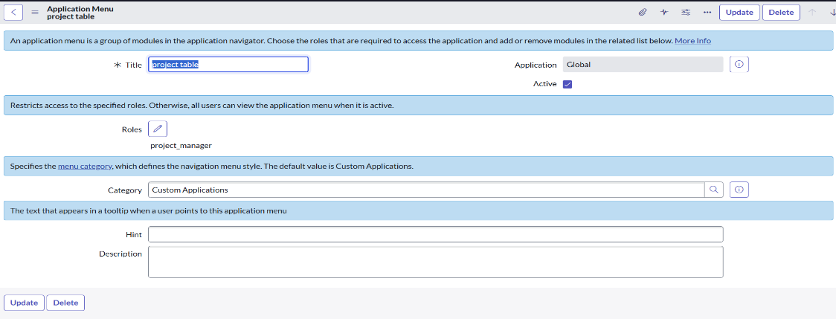

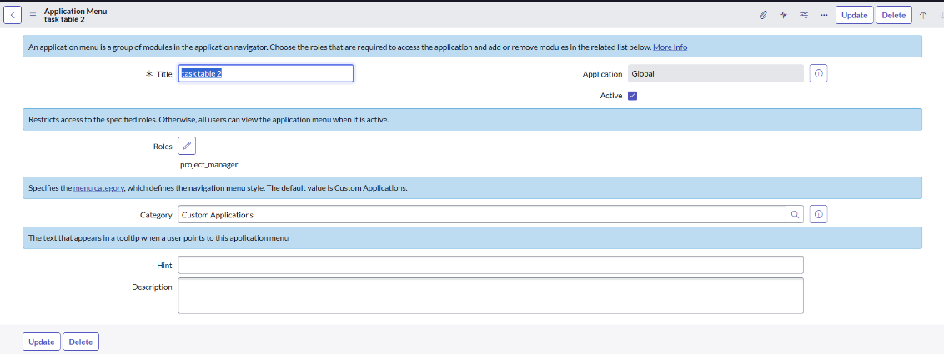

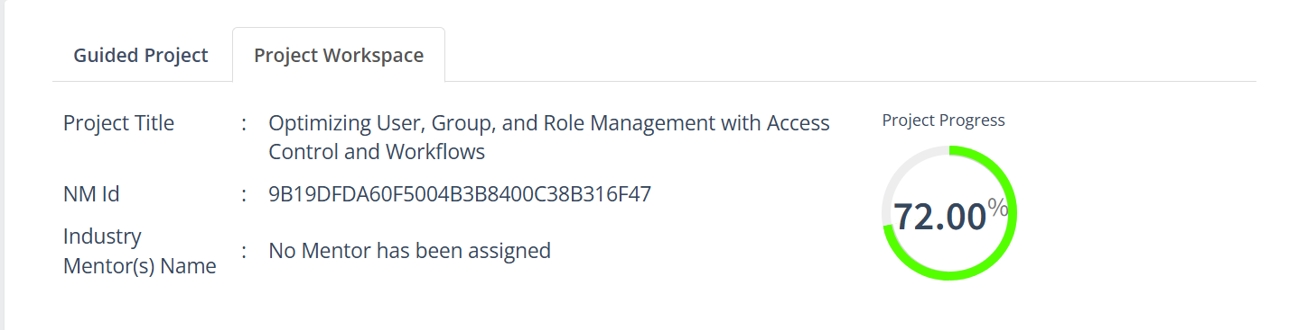

**8. Create ACL (Access Control List) in ServiceNow**

1. **Log in** to ServiceNow.
2. Navigate to **All → ACL** from the left menu.
3. Under **System Security**, select **Access Control (ACL)**.
4. Click **Elevate Role** to gain admin privileges for creating ACLs.
5. Click **New** to create a new ACL.
6. Fill in the ACL details:
   * **Table/Field** – Specify what you want to control access to.
   * **Operation** – Choose the type of access (Read, Write, Create, Delete).
   * **Roles** – Select the roles that should have access.
7. Click **Submit** to save the ACL.

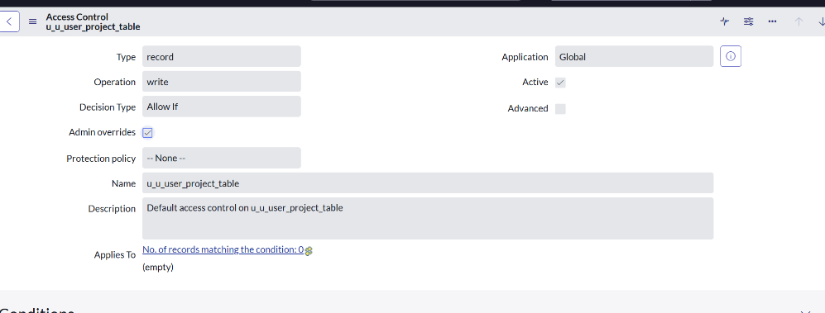

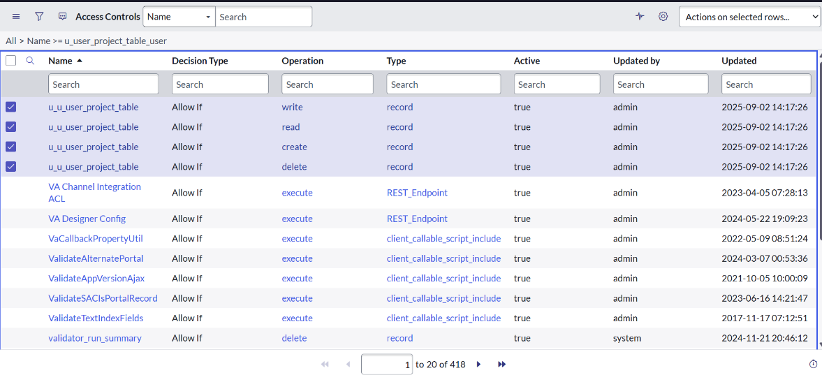

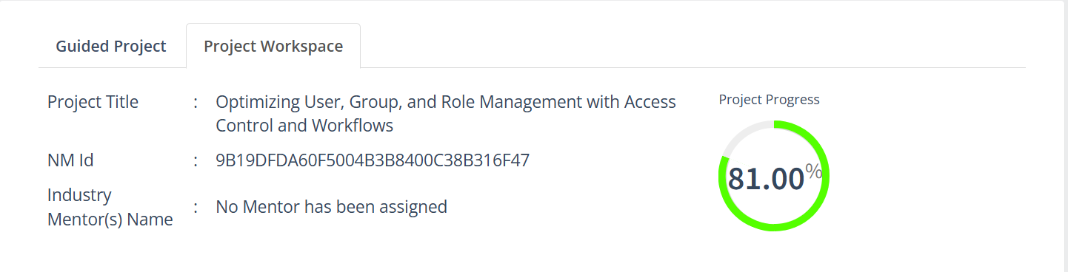

**9. Create a Flow to Assign Operations Ticket to a Group in ServiceNow**

**Step 1: Open Flow Designer**

1. **Log in to ServiceNow.**
2. **Navigate to All → Flow Designer from the left menu.**
3. **Open Flow Designer under Process Automation.**
4. **Click New → Flow.**
5. **Fill in the flow details:**
   * **Flow Name: Task Table**
   * **Application: Global**
6. **Click Build Flow.**

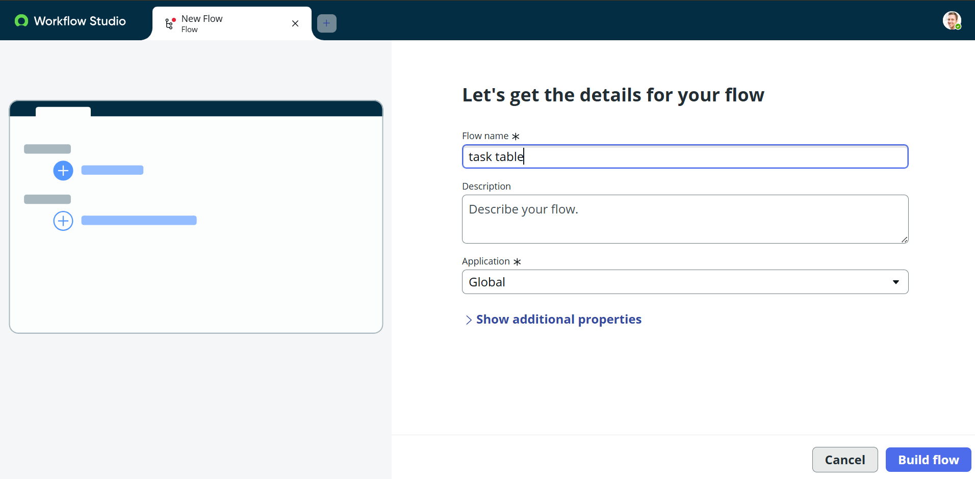

**Step 2: Add a Trigger**

1. **Click Add a Trigger.**
2. **Search for Create Record and select it.**
3. **Choose Table Name: Task Table.**
4. **Add the following conditions:**
   * **Status → is → In Progress**
   * **Comments → is → Feedback**
   * **Assigned To → is → Bob**
5. **Click Done.**

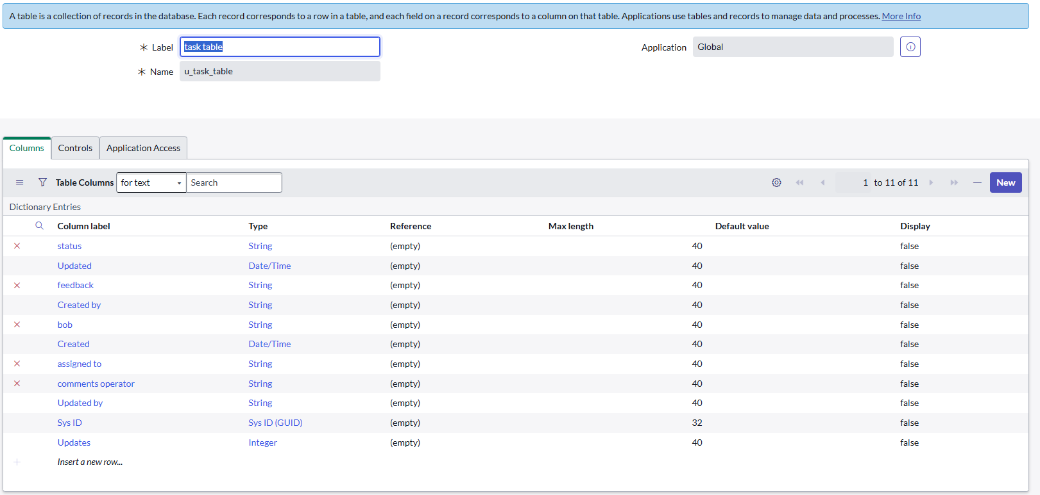

**Add Actions in Flow Designer**

**Step 3: Add Update Records Action**

1. **Click Add an Action.**
2. **Search for Update Records and select it.**
3. **Drag the necessary fields from the Data Pill (right side) into the record fields.**
4. **The Table will auto-fill.**
5. **Set the field:**
   * **Status = Completed**
6. **Click Done.**

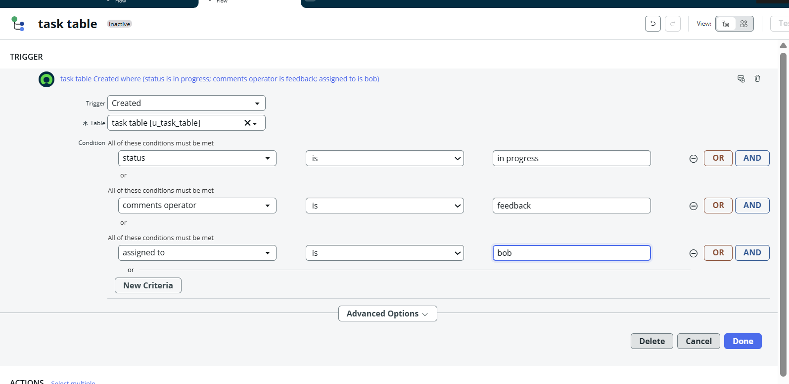

**Step 4: Add Approval Step**

1. **Under Actions, click Add an Action.**
2. **Search for Ask for Approval and select it.**
3. **Drag the record fields from the Data Pill; the Table will auto-fill.**
4. **Fill in the approval details:**
   * **Approval Field: Status**
   * **Approver: Alice P**
5. **Click Done.**

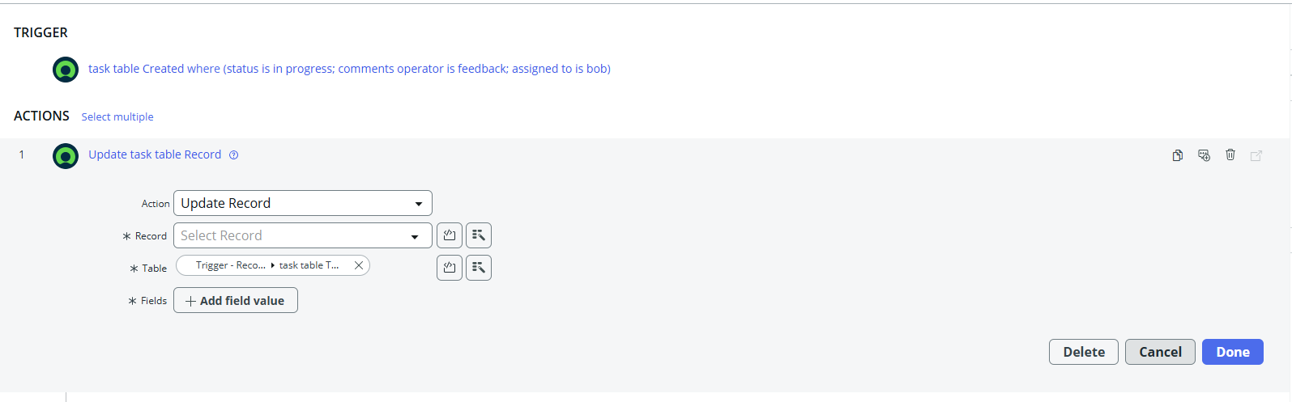

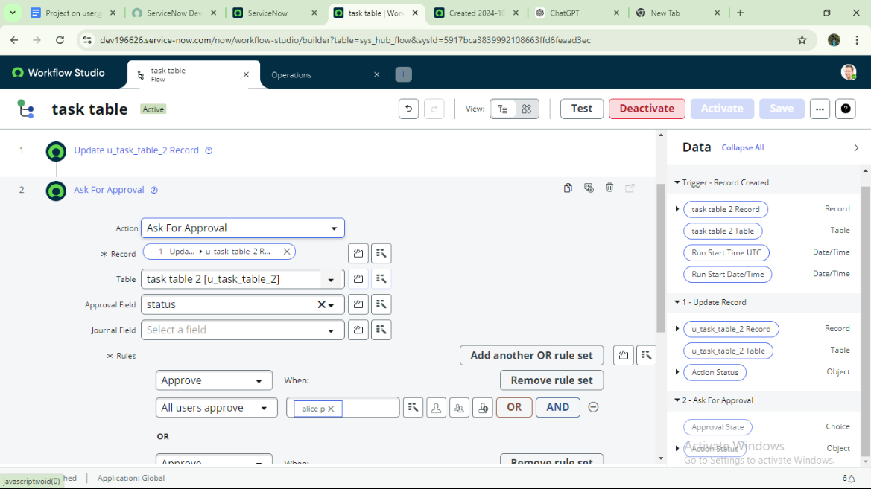

**Add Actions in Flow Designer**

**1. Update Records Action**

* **Click Add an Action and select Update Records.**
* **Drag the required fields from the Data Pill into the record fields; the table auto-fills.**
* **Set Status = Completed.**
* **Click Done.**

**2. Approval Action**

* **Click Add an Action and select Ask for Approval.**
* **Drag the record fields from the Data Pill; the table auto-fills.**
* **Set approval details:**
  + **Approval Field: Status**
  + **Approver: Alice P**
* **Click Done.**

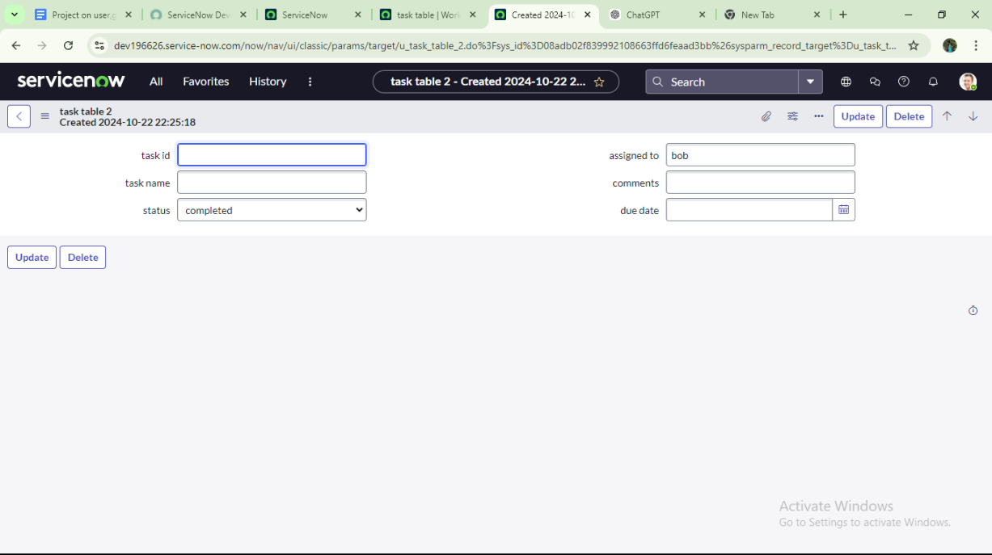

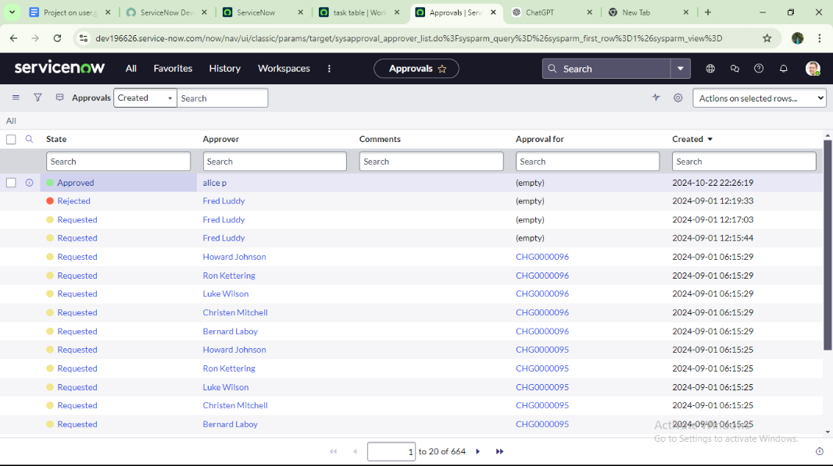

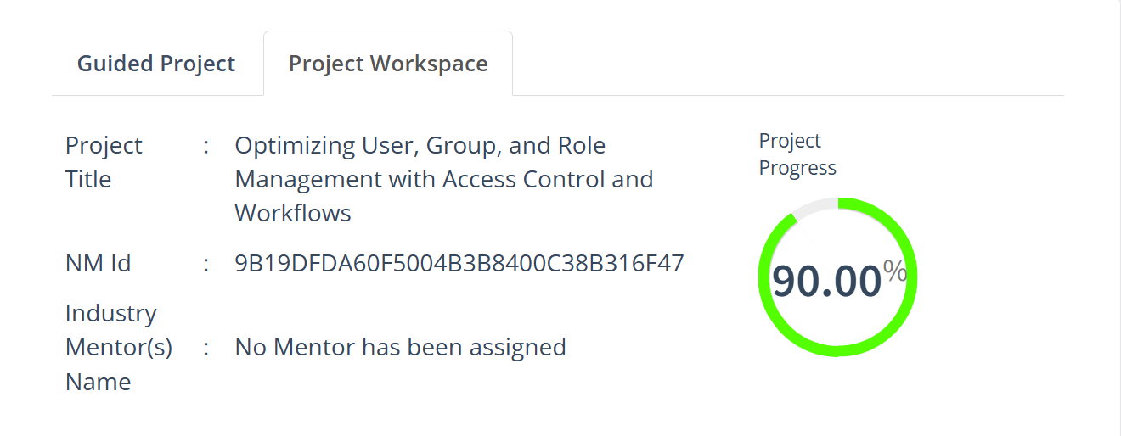

**Conclusion**

A structured approach to project management with clearly defined roles ensures balanced responsibilities and effective collaboration. Utilizing tables to organize information simplifies tracking of tasks and progress, promotes accountability, and enhances communication, ultimately supporting smooth project execution and successful completion.